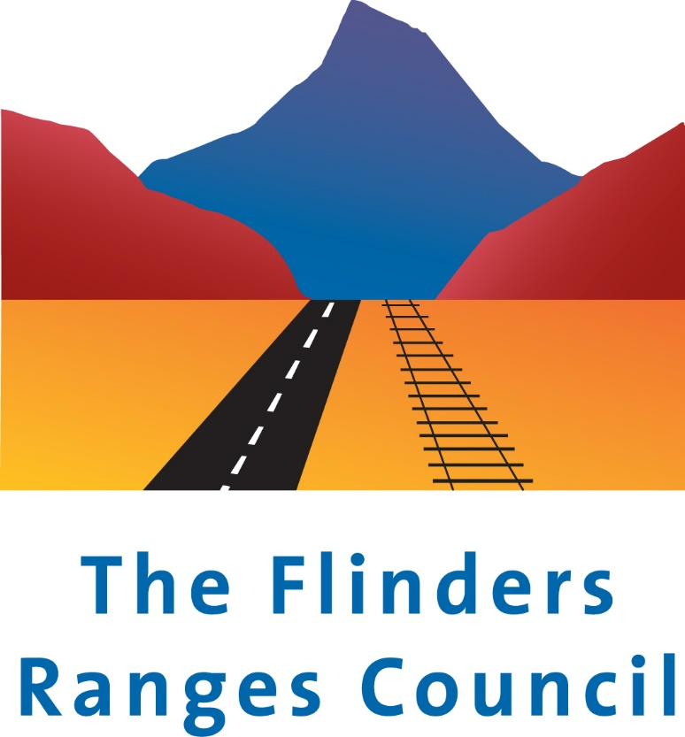
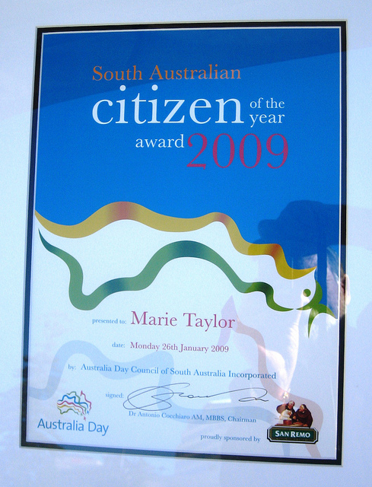
The Flinders Ranges Council
Australia Day Awards 2021
Nomination Form

The Flinders Ranges Council Australia Day awards celebrate the achievement and contributions of individuals who are Australia citizens and community organisations within our community. There are three award categories Young Citizen of the Year – a person under the age of 30 as of the 26/01/21 who has given outstanding service to our community during 2020 and the Citizen of the Year - a person who has made a considerable contribution or given outstanding service to our community over a number of years. Community Event or Project of the Year - an event/project complete during 2020 or over many previous years that has benefited the local community.
Nominations close Friday 8th January 2021
Nomination Information

Nomination Category: _____________________________________________________

Title:_________ Name:_______________________________________________________

Community Event/ Project Name: ___________________________ Organisation: ______________________________
(if applicable)
Address:______________________________________________________________

Telephone: ______________________ Email: _______________________________________________

Signature: __________________________ Date: ______________ Is the Nominee aware of nomination: Yes / No
Selection Criteria

Why do you believe the nominee should receive the nominated award?

What impact does the nominee have on the community?

Is there an ongoing benefit to the community?

How is the nominee an inspirational role model for the community / how did the event contribute to the community?

Other significant contributions and achievements: (If required please attach additional pages)

.

Nominator Details

Title: ______________ Name:__________________________________________________

Address:_________________________________________________________________________

Telephone: _________________________________ Email: ______________________________

Signature: _____________________________________ Date: ________________________

Please email nomination forms marked “Confidential” Australia Day Nomination to: australiaday@frc.sa.gov.au
Or deliver in a sealed envelope to the Council Office, 1 Seventh Street, Quorn
Privacy Policy Statement
All personal information collected by the Council is to be used only for the purpose of conducting
business in accordance with the Local Government Act 1999, and other relevant Acts under which the Council is charged with any responsibility and in the provision of Council services to the Council’s residents and/or ratepayers and/or visitors to the Council area. Please see web site www.frc.sa.gov.au/policies for full details.

