The Flinders Ranges Council
Citizen of the Year Awards 2026
Nomination Form

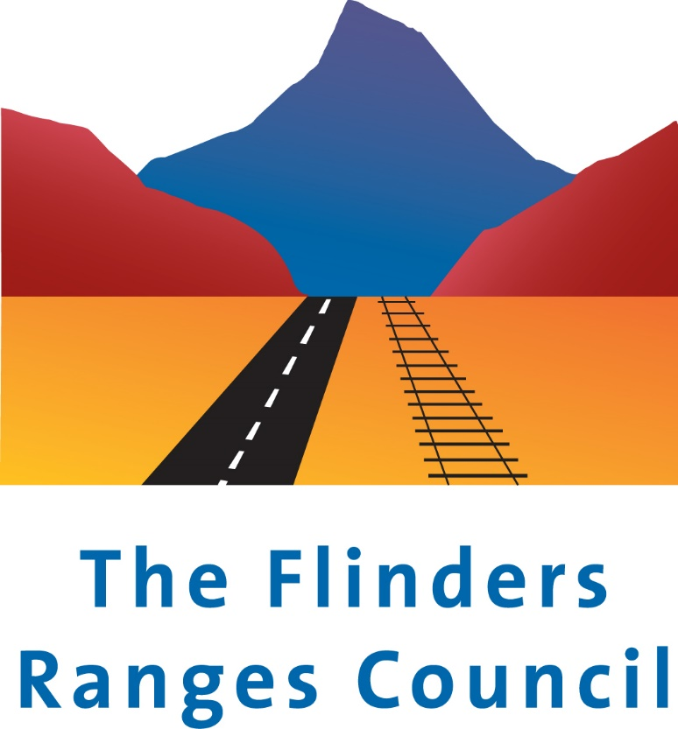

The Flinders Ranges Council Citizen of the Year Awards celebrate the achievement and contributions of individuals who are Australian citizens and community organisations within our community. There are three award categories:
- Citizen of the Year - a person who has made a considerable contribution or given outstanding service to our community over a number of years.
- *Young Citizen of the Year – a person over the age of 16 and under the age of 30 as of the 26/01/26 who has given outstanding service to our community during 2025 or over multiple years.
- Community Event of the Year - an event held during 2025 that has benefited the local community.
- Award for Active Citizenship – a person or group that has delivered outstanding work on an event or project for the community during 2025.
Nominations close 5pm Wednesday 7 January 2026
Nominee Information
(the person/organisation you would like to nominate)

CITIZEN YOUNG CITIZEN COMMUNITY EVENT ACTIVE CITIZENSHIP

Name:________________________________________________________________________

Address:__________________________________________________________________________________________

Telephone: ________________________________ Email: _______________________________________________

Date of Birth: ___________________ Is the person being nominated an Australian citizen? Yes No
Selection Criteria

How has the nominee contributed to the community?

How has the nominee demonstrated an enhancement of life for the community?

What is or has been the ongoing benefit to the community?

How is the nominee an inspirational role model for the community / how did the event contribute to the community?

Other significant contributions and achievements or testimonials: (If required please attach additional pages)

.

* Any nominations made by parents or members of families for a child or sibling must be accompanied by an independent letter of support to back up the nomination

Nominator Details

Name:___________________________________________________________________

Address:__________________________________________________________________________________________

Telephone: ________________________________ Email: ________________________________________________

Signature: _____________________________________ Date: ________________________

Please email nomination forms marked “Confidential” Australia Day Nomination to: australiaday@frc.sa.gov.au
Or deliver in a sealed envelope to the Council Office, 1 Seventh Street, Quorn
Privacy Policy Statement
All personal information collected by the Council is to be used only for the purpose of conducting business in accordance with the Local Government Act 1999, and other relevant Acts under which the Council is charged with any responsibility and in the provision of Council services to the Council’s residents and/or ratepayers and/or visitors to the Council area. Please see web site www.frc.sa.gov.au/policies for full details.

